TExT Templates
Brief Technical Guide

June 2024
V24.1

A Few Words

This is a brief Technical companion guide for use primarily with the OXYL8 – Word/Embedded Excel TExT Template

There may be errors and omissions – if so please do get in touch on the below email to let us know:-

admin@oxyl8.com

If you have any ideas for improving the functionality or layout of the Template then please do drop us an email.



Bill Cassells
20.06.24

OXYL8 TExT Templates (Word/Excel)

Although there are two (similar) versions of the Template – this guide is primarily geared to assisting with amending the tables, layout etc on the “Embedded” Word/Excel Template version.

General Introduction

The ‘embedded’ Template permits automatic calculation of; eg areas, velocities, flowrates etc from base data.

It is quite possible therefore that the Template could be used on a (rugged) laptop or tablet for direct preparation of TExTs on site (saving office time).

We’d love to hear feedback on this possibility.

Rugged Tablets:- https://www.samsung.com/uk/tablets/others/galaxy-tab-active-pro-sm-t545-10-1-inch-black-64gb-lte-sm-t545nzkau07/

Rugged Laptops:- https://www.dell.com/en-uk/shop/laptops-2-in-1-pcs/sf/rugged-laptops

In principle – this Template is a Word file with Excel tables ‘embedded’ in it.

Remember: When using this ‘embedded’ version of the Template – double mouse click on the embedded table to open it out as an Excel table.

Then enter your data.

When finished – click again outside the table (once) on the document part and it will close the table again. Simples?

Both the Template and the supporting individual Excel Tables (files) are available for download here:-

https://oxyl8.com/

While I believe it is possible to amend the embedded tables in the Word document – it is probably easier to amend the Excel table (as an Excel file) and then re-embed it into the Word document.

The following pages will take you through the simple process for amending tables and re-embedding them into the Template.

Oh? Do always keep a separate pristine unadulterated copy of your files/tables before amending anything. Trust me – it can save a lot of teeth grinding and bad words .

Word Tables

Most of the tables in the Template have been constructed as pure Word tables.

Tables 14. 15a. 15b. 15c. and C1. (In Partial Enclosure Appendix) are however “embedded” Excel tables.

To amend a Word Table – simply position your mouse pointer on the table (row, cell or column you wish to amend) and right click. You will then be presented with the options in the pop-up below:-
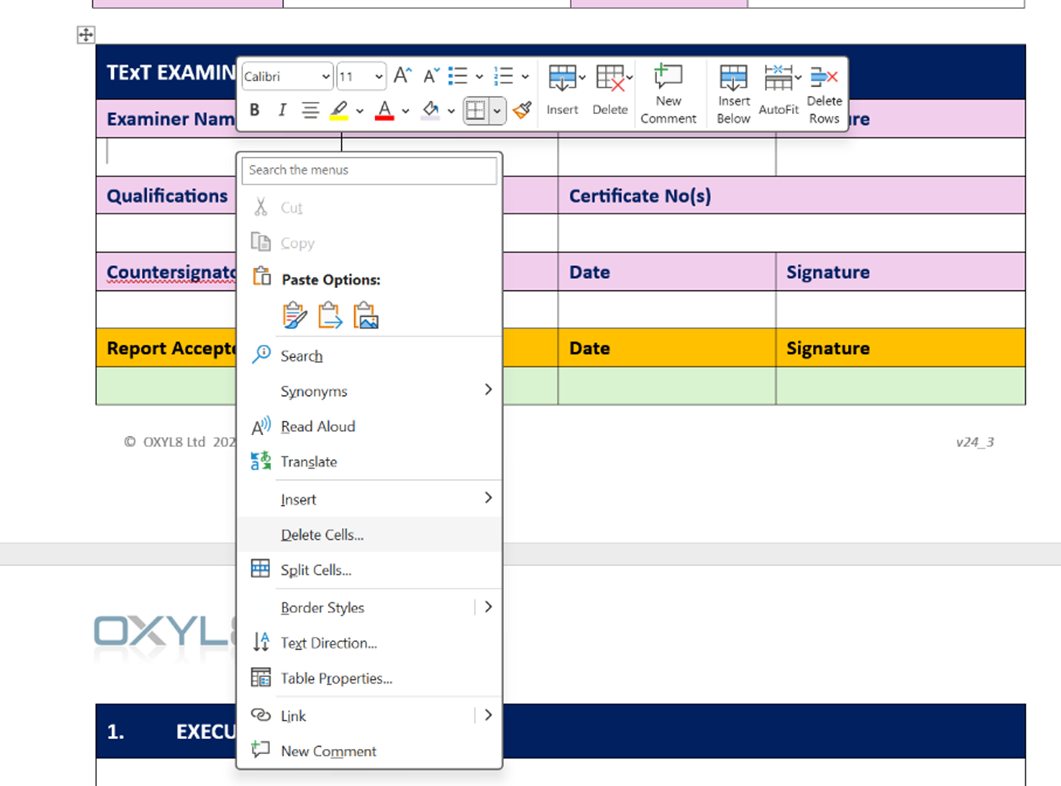

“Insert” will allow you to insert a Row, Column or Cell.
“Delete” – deletes a Row, Column or Cell

“Table Properties” opens up another window (see next page)

This new pop-up window permits most aspects of the Rows, Columns or Cells to be amended.

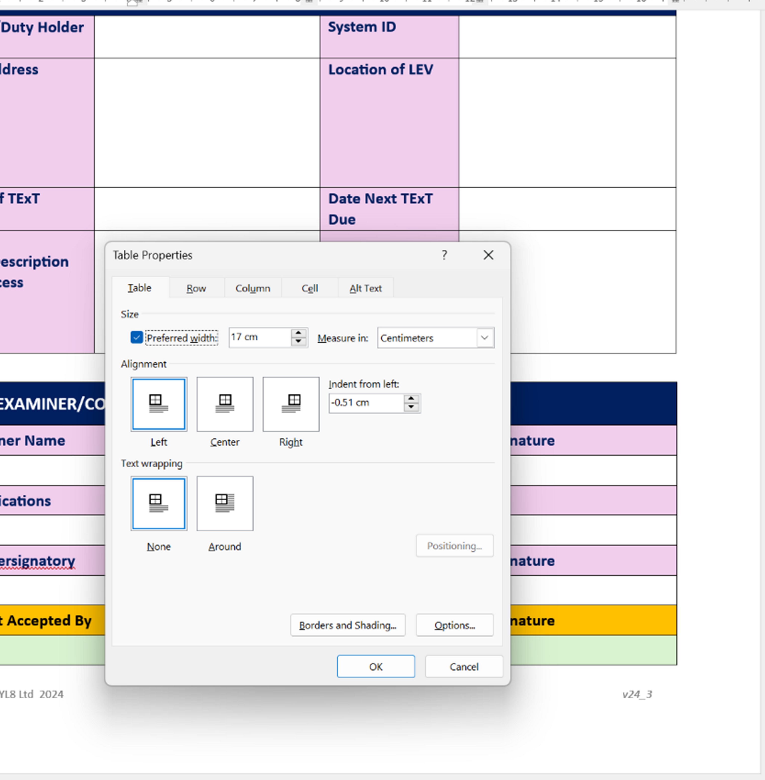

Excel Tables and Embedding into Word Template

The individual Excel tables can be amended and improved using standard Excel functions.

Once an Excel table has been changed to suit your company’s needs ….. first delete the old embedded Excel table from the Word Template by clicking ONCE on it in the Template and then hitting the “Delete” button on your keyboard.

To ‘Insert’ the new Excel table – first from the Word Template top line click the “Insert” tab and then select “Object” – as arrowed in image below:-
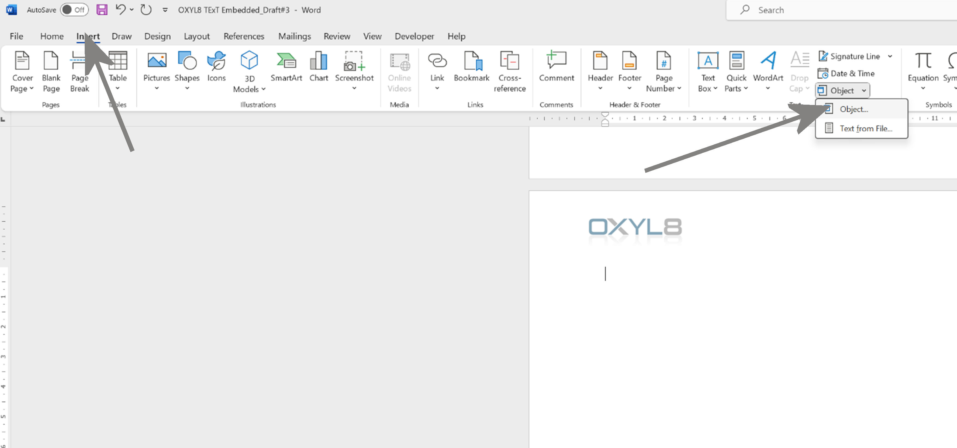

Clicking “Object” will open a pop-up window …… select the tab “Create from File”. Then use the “Browse” button to navigate to the Excel table you have created/amended.
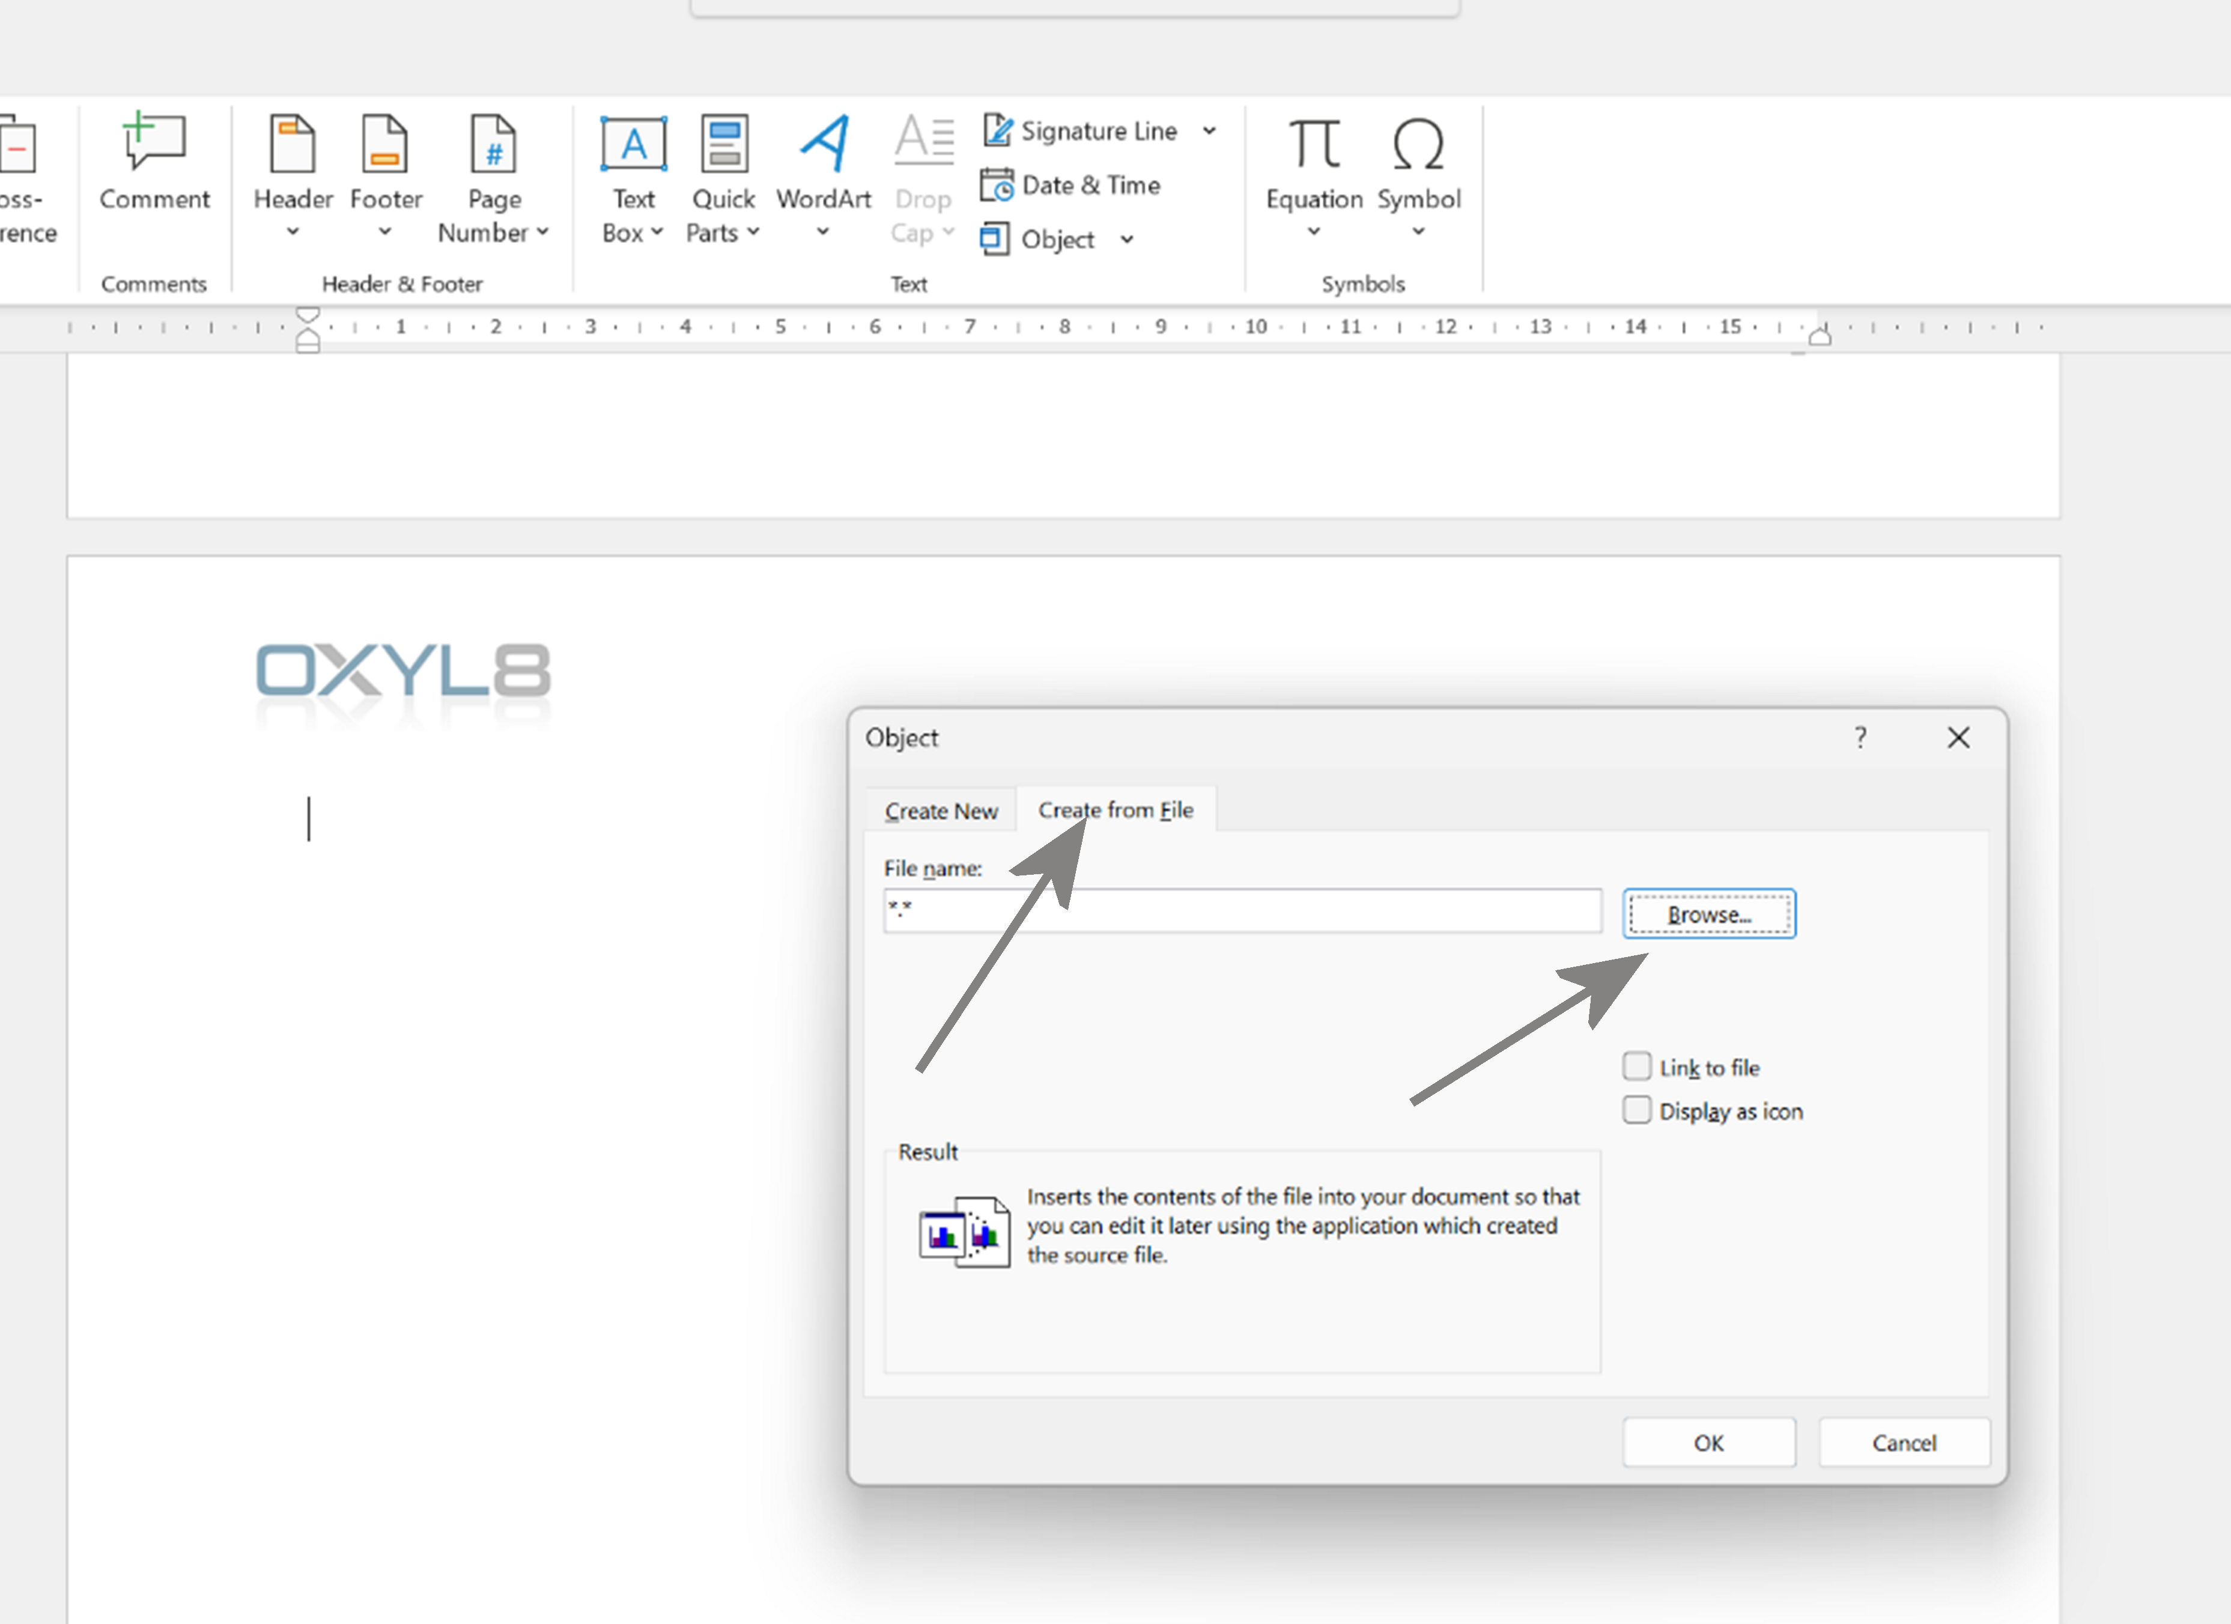

Once you have browsed to the Excel file and clicked “Insert” and then clicked “OK” … that should do the trick and your Excel table will now be embedded into the Word Template.

Resave the Template as a new version.

