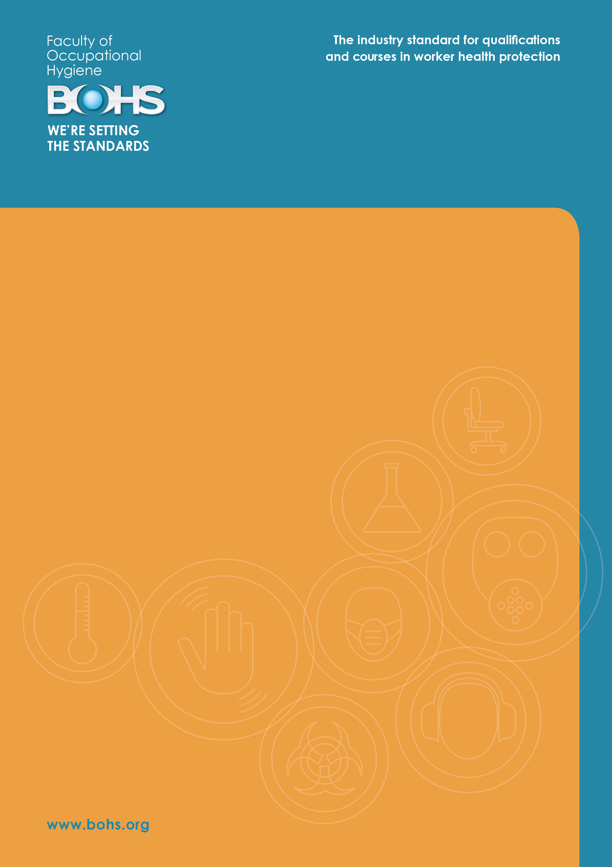

Issue 1 | November 2016

P600 Foundation Course
Methods for Testing the Performance of Local
Exhaust Ventilation Systems
Course Specification

Contents
 |  | Page
Section 1 | About BOHS | 2
Section 2 | P600 at a glance | 3
Section 3 | Background to the course | 4
Section 4 | Key features of the course | 5
Section 5 | Delivering the course | 7
Section 6 | Syllabus | 9
Section 7 | References and further reading | 13
Section 8 | Completing the course | 14
Section 9 | Quality assurance | 21
Section 10 | Offering the course | 22
Section 11 | Other courses and qualifications for asbestos practitioners | 23

Section 1
About BOHS

BOHS - The Chartered Society for Worker Health Protection
BOHS is the Chartered Society for Worker Health Protection. Our vision is to create a healthy working environment for everyone by preventing exposure to hazardous substances in the workplace.
Founded in 1953, we have developed over the last 60 years into a highly respected and influential body on workplace health issues, working closely with organisations in the UK and overseas to promote our vision. We are a registered charity, professional society and a member of the International Occupational Hygiene Association, which is recognised as a non-government organisation by the International Labour Organisation (ILO) and the World Health Organization (WHO).
We were awarded a Royal Charter in 2013 in recognition of our pre-eminent role in protecting worker health.
BOHS is a membership organisation, open to anyone who has an interest in workplace health issues, and we have over 1,800 members in 57 countries.

BOHS courses and qualifications – the quality choice
We are the leading awarding body in our field. Our UK courses and qualifications are recognised and respected by independent agencies such as the Health and Safety Executive (HSE) and the United Kingdom Accreditation Service (UKAS), and further afield by industry and employers worldwide. Over 60,000 people have taken one of our qualifications through our network of training providers.
Our courses and qualifications are overseen by a team of highly experienced professionals, who are dedicated to developing the competence and career opportunities for the many thousands of people that play a key role in protecting worker health; in diverse fields such as asbestos, legionella and control technologies.
Information about all our courses and qualifications is available on our website:
www.bohs.org/qualifications-training/bohs-qualifications/

Section 2

P600 at a glance

What is the objective?
To enable candidates to identify and correctly use appropriate flow visualisation and measurement techniques to test the performance of local exhaust ventilation (LEV) systems.
Who is it for?
Anyone responsible for operating or maintaining LEV systems as part of their work. This includes engineers, managers, supervisors, equipment designers and technicians.

Anyone who requires a foundation level of understanding of LEV systems in order to progress to a Level 4 qualification (P601-4 series).
What are the entry requirements?
Candidates are expected to have some basic knowledge of the measurement systems used to assess the performance of LEV systems.
What are the main subject areas?
- Basic components of local exhaust ventilation systems.
- Qualitative visualisation techniques.
- Quantitative measurement techniques.
How long does it take?
Normally one day.
What level is it?
Level 3 in the BOHS qualifications framework.
How do candidates pass it?
Candidates must pass a 30 minute multiple-choice examination within 12 months.

Section 3
Background to the course
BOHS has provided LEV proficiency qualifications in the UK for over 10 years, working closely with globally recognised bodies such as the HSE to set educational standards and to spread best practice. In that time, over 2,000 candidates have taken a BOHS LEV examination.

BOHS is designing a new suite of Foundation courses, which gives the candidates a basic understanding of a subject so that they can then either progress in a specific career or take a proficiency qualification.

P600 - Methods for Testing the Performance of Local Exhaust Ventilation Systems focuses on the fundamentals of LEV systems, from their components to measurement and testing techniques. It will give candidates the necessary skills and knowledge in order to progress into careers that involves using LEV (e.g. engineers, technicians), and prepares them for taking BOHS Level 4 Proficiency qualifications.

Section 4
Key features of the course
Objective
To enable the candidates to identify and correctly use appropriate flow visualisation and measurement techniques to test the performance of local exhaust ventilation (LEV) systems, to a standard which protects health in the workplace and minimises risk of hazard exposure.

Target audience
This course is suitable for anyone who:

- Is responsible for operating or maintaining LEV systems as part of their work (e.g. engineers, managers, supervisors, equipment designers, technicians).
- Wishes to train to become an LEV tester, technician or maintenance engineer
- Requires a basic level of understanding of LEV systems in order to take a Level 4 Proficiency qualification (P601-4).

Entry requirements
Candidates are expected to have some basic knowledge of the measurement systems used to assess the performance of LEV systems

There are no work experience requirements, although it is an advantage for candidates to have worked in a role involving LEV.

Level
The level of a course or qualification indicates the relative complexity and depth of knowledge and skills required to complete the course or qualification.

This course is set at Level 3 in the BOHS qualifications framework.

Fees
The examination fee for each candidate is published on the BOHS website:
www.bohs.org/qualifications-training/examination-fees/

Section 5
Delivering the course
Teaching and learning time
The P600 course normally runs over one day and includes at least six hours of teaching.

The course can be delivered more flexibly, such as an evening or part day course, but should still include six hours of teaching.

Tutors
The course should be taught by tutors who are experienced and qualified LEV practitioners. As a guide, tutors will typically have:

- At least three years’ experience in working with LEV systems;
- A recognised LEV qualification or a professional occupational hygiene qualification.

Teaching resources
Training providers must have the following facilities and equipment:

- Pitot tubes with micro-manometer, vane and thermal anemometers.
- Ventilation systems with suitable measurement points.
- Smoke tubes or smoke generator.
- Dust lamp.
- Photographic examples for education purposes.

Section 6
Syllabus
The course is structured into four sections, each with an indicative time allocation:

Section Time allocation
1 Basic components of local exhaust ventilation systems 10%
2 Qualitative visualisation techniques 20%
3 Quantitative measurement techniques 30%
4 Practical work 40%

Educational objectives
Under supervision, candidates should be able to carry out a series of observations and physical measurements, to allow an objective assessment of the performance of a local exhaust ventilation system.

The numbers in brackets refer to the publications listed in ‘References and further reading’ in Section 7.

1 Basic components of local exhaust ventilation systems (10%)

    - Describe the basic components of local exhaust ventilation (LEV) systems (i.e. inlets,
ductwork, air cleaners, air movers, ventilation hoods and discharges). Explain their function in the LEV system and the best practice design principles of such systems.

2 Qualitative visualisation techniques (20%)

2.0.1 Describe and demonstrate the use of smoke generators and/or smoke tubes to
visualise air flows in and around LEV systems.
2.0.2 Describe and demonstrate the use of a dust lamp to visualise fine airborne dust, and
how this technique can assist in assessing the effective control of fine dust from a range of processes.

3 Quantitative measurement techniques (30%)

3.0.1 Describe the principles of operating a pitot tube/manometer combination.
3.0.2 Describe and demonstrate how to carry out a pitot tube traverse to determine static pressure, velocity pressure, and then determine the velocity in a ducted ventilation system.
3.0.3 Describe the principle of operation of a vane anemometer and a hot wire anemometer.
3.0.4 Describe and demonstrate how and where to undertake measurements in relation to the inlets of an LEV system.
3.0.5 Understand which test equipment to use for which measurements and how to use them correctly.

4 Practical work (40%)

4.1 Visual assessments
Appropriate techniques to visualise air flows as a means of assessing the ability of LEV systems to control hazardous substances.
4.1.1 Use of smoke generators and/or smoke tubes.
4.1.2 Use of dust lamps.
4.2 Physical measurements
Appropriate methods to actually measure performance of ventilation systems.
4.2.1 Practical operation of a pitot tube/manometer combination.
4.2.2 Measurement of air velocity with anemometers.
4.3 Safety requirements
4.3.1 Personal protection requirements.

Section 7
References and further reading
 | 1 | ACGIH (2013), Industrial Ventilation: A Manual of Recommended Practice for Design
 | 2 | HSE (2016), COSHH essentials: www.hse.gov.uk/coshh/essentials
 | 3 | HSG258 (2011), Controlling airborne contaminants at work: A guide to local exhaust ventilation (LEV), HSE
 | 4 | INDG408 (2008), Clearing the air: a simple guide to buying and using local exhaust ventilation (LEV), HSE
 | 5 | L5 (rev 2013), The Control of Substances Hazardous to Health Regulations 2002: Approved Code of Practice and Guidance, HSE
 | 6 | MDHS 82/2 (2015), The dust lamp: a simple tool for observing the presence of airborne particles, HSE Books
HSE guidance is reviewed and revised periodically. Training providers should check that the publications listed above are the current versions.
Useful websites

All the Health and Safety Executive (HSE) publications listed above are available as free downloads from the HSE website: www.hse.gov.uk/

Section 8
Completing the course
Candidates are required to pass one written examination to complete the course.

Multiple-choice examination
The written examination usually takes place at the end of the course. It enables candidates to demonstrate that they have fully understood the course content and how to test and measure the performance of LEV systems.

The examination is comprised of 20 multiple-choice questions, to be answered in 30 minutes. For each question, candidates will choose one of four possible answers. The questions are a mix of text and diagram-based questions.

The questions are worth one mark each. Candidates will be awarded 1 mark for a correct answer, and 0 marks for an incorrect answer.

Candidates should attempt all questions as no marks are deducted for incorrect answers.

The examination covers sections 1 to 3 of the syllabus content, in proportion to the time allocation given for each section. This gives a mark allocation as follows:

Section |  | Number of marks
1 | Basic components of local exhaust ventilation systems | 3
2 | Qualitative visualisation techniques | 7
3 | Quantitative measurement techniques | 10

The sections are clearly marked in the examination paper.

The examination is a closed-book examination, which means that candidates are not permitted to have access to any materials.

Invigilation
The examination is invigilated by the training provider, to help ensure that all candidates demonstrate their true level of attainment.

Marking and results
All examination papers are marked by BOHS.

Candidates receive their results in writing from BOHS. The results are reported as pass or fail plus a percentage.

Training providers are sent a list of results for all candidates on a course.

Feedback
Candidates receive feedback on their examination performance. For example, the feedback for an examination in which a candidate scored 80% would be shown as follows:

Syllabus Area |  | Result
1 | Basic components of local exhaust ventilation systems | 2/3 | (66%)
2 | Qualitative visualisation techniques | 7/7 | (100%)
3 | Quantitative measurement techniques | 7/10 | (70%)
Total |  | 16/20 | 80%

Training providers receive feedback on the performance of all candidates.

Written Exam Performance against syllabus |  |  |  |  | Number of candidates in each scoring band
 |  |  |  |  | 0-74% | 75-100%
P600 Written Exam | 1: Basic components of local exhaust ventilation systems |  |  |  | 1 | 6
P600 Written Exam  P600 Written Exam | 2: Qualitative visualisation techniques |  |  |  | 1 | 6
 | 3: Quantitative measurement techniques |  |  |  | 1 | 6

Resits
Candidates may re-sit the examination, but must pass within 12 months of the original sitting.

Certification
Candidates who pass the course will receive a certificate of successful course completion.

Section 9
Quality assurance
Internal quality assurance
Training providers must operate an internal quality assurance system which evaluates and improves the delivery of the course.

External quality assurance
BOHS undertakes desk-based reviews of documents, including teaching materials, and conducts surveys of candidates. We also reserve the right to make unannounced visits to training providers to ensure that the examinations are conducted in line with our requirements.

Section 10
Offering the course
Approved training providers
Please complete and return the ‘Application to Offer Additional Qualifications’ form to qualifications@bohs.org. The form is available on the BOHS website.

New training providers
Please send an email to qualifications@bohs.org expressing your interest in offering the course, and we will advise you about the approvals process.

Section 11
Other courses and qualifications
Candidates who complete this course may wish to progress onto P601 - Thorough Examination and Testing of Local Exhaust Ventilation Systems.
For more information on our courses and qualifications, please visit www.bohs.org/qualifications-training.

© British Occupational Hygiene Society 2016
Information in this course specification is correct at the time of issue but may be subject to change.

BOHS  5/6 Melbourne Business Court  Millennium Way  Pride Park  Derby  DE24 8LZ | Incorporated by Royal Charter  No. RC000858  Registered Charity  No. 1150455

